Table of Contents

Use Case story: 1

The Data: 1

Feature Extraction: 1

Do below changes in the docker file. 2

Push image to docker hub/ QUAY/ARTIFACTORY Repository. 2

Check the image on dockerHub. 2

Map image on vantage cluster 3

# **Use Case story:**

We wanted to explore the following user story:

'As a retailer, I would like to reduce stock of a given level based on a certain number of days into the future while optimizing for margin.'

We used a combination of data simulation, Bayesian Time Series Modelling and Optimisation to determine the optimum markdowns to liquidate stock over a given time period.

# **The Data:**

The pricing models run for 8 products (Con, Syn Syn, High, Wiper, Air, Cabin and Radi) Currently the analysis looks at 287 shops (no franchise shops) and new shops that come online will automatically be included unless added to exclusions list. The Start date is set at January 1st , 2018 and new daily data will be added as it arrives.

# **Feature Extraction:**

Feature extraction involves reducing the amount of resources required to describe a large set of data. When performing analysis of complex data one of the major problems stems from the number of variables involved. Analysis with a large number of variables generally requires a large amount of memory and computation power and it may cause model overfitting

feature extraction is very important it starts from an initial set of measured data and builds derived values ([features](https://en.wikipedia.org/wiki/Feature_(machine_learning))) Feature extraction is a [dimensionality reduction](https://en.wikipedia.org/wiki/Dimensionality_reduction) process, where an initial set of raw variables is reduced to more manageable groups (features) for processing,

When the input data to an [algorithm](https://en.wikipedia.org/wiki/Algorithm) is too large to be processed and it is suspected to be redundant then it can be transformed into a [feature vector](https://en.wikipedia.org/wiki/Feature_vector). Determining a subset of the initial features is called features extraction.

# **Connecting with Vantage cluster within docker container:**

1. Download the JDBC file form Teradata site and put it into the docker container as below.

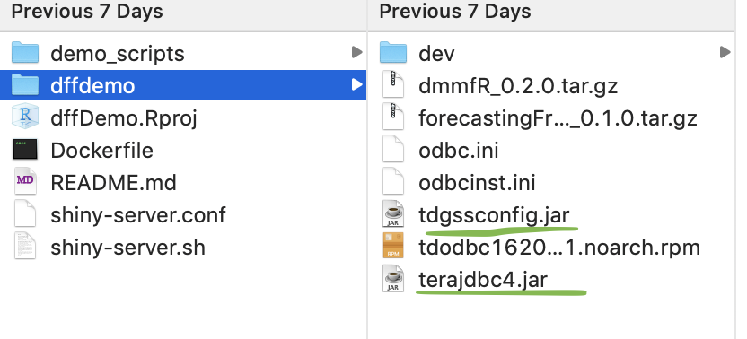

# **Do below changes in the docker file.**

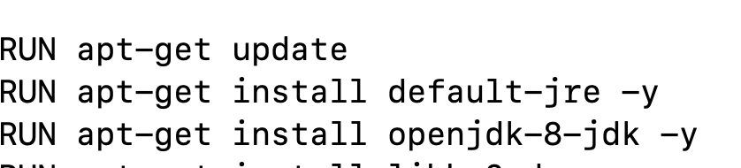

Build Docker images.

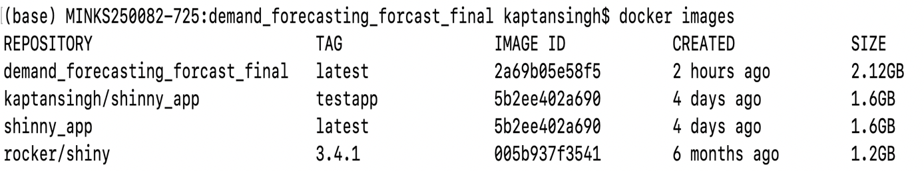

# **Push image to docker hub/ QUAY/ARTIFACTORY Repository.**

1. docker login --username=yourhubusername --email=youremail@company.com
2. docker tag bb38976d03cf yourhubusername/RepositoryName:tagname(anything)
3. docker push yourhubusername/ RepositoryName

# **Check the image on dockerHub.**



# **Map image on vantage cluster.**

* go to link <https://tdap790m1.labs.teradata.com/>
* Go under Developed and click on Create like below.
  + 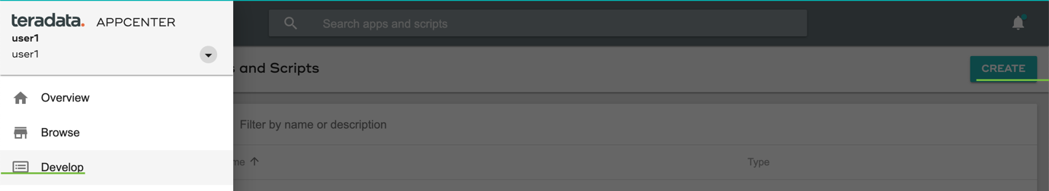
* Mention the name of application and save.
* Open the application and you need to fill below details and save.
  + 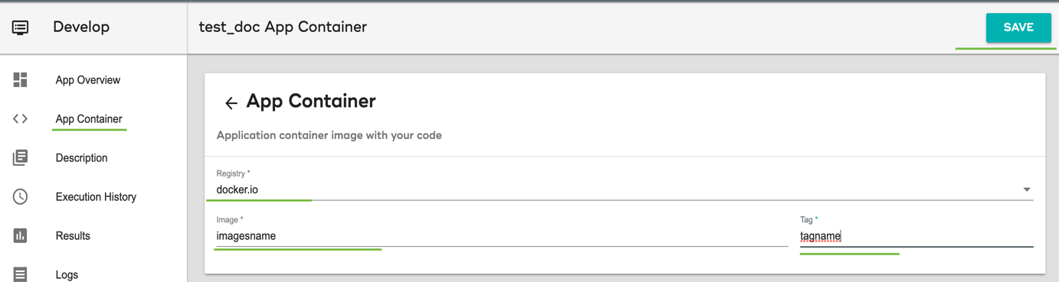
* Now you can “START” the app and see the output like below.

